# MySQL Train Booking Project

**1.Project Objective:**

The objective of this project is to design and implement a Train Ticket Booking Database System using MySQL. The system allows passengers to book tickets, view train schedules, manage reservations, and generate reports such as seat availability and revenue summaries.

This project provides hands-on experience in:

* Database design (ER model)
* Writing SQL queries, views, stored procedures
* Data analysis using Excel

**2. Modules Covered**

| **Module** | **Description** |
| --- | --- |
| **Passenger Module** | Stores personal info of passengers |
| **Train Module** | Contains train numbers, names, routes, and timings |
| **Booking Module** | Manages ticket booking details including date, train, and seat info |
| **Seat Availability** | Tracks seat count for different classes |
| **Admin Reporting** | Generates reports for booked tickets, route-wise demand. |

**3. Key Tables**

* passengers(passenger_id, name, age, gender, contact)
* trains(train_id, train_name, source, destination, departure_time, arrival_time)

**4. Sample Queries**

* Book a ticket and update seat availability
* Show available trains from A to B on a specific date
* Find the number of passengers on a specific train

**5. Tools & Technologies**

* **Database:** MySQL
* **Reporting:** Excel Dashboard (for analysis)
* **SQL Concepts:** Joins, Views, CTEs, Stored Procedures, etc

**6. Expected Outcomes**

* A well-structured relational database system
* Efficient SQL queries for data management and analysis
  + Total bookings by route/class
  + Revenue per month
  + Train utilization rates

**7. Future Enhancements**

* Add login system for admin and users
* Implement waitlisting and cancellation logic
* Integrate live train running status (via API)

SQL QUERIES

-- Create Database

CREATE DATABASE IF NOT EXISTS TrainBooking;

USE TrainBooking;

-- Create Tables

CREATE TABLE IF NOT EXISTS Stations (

station_id INT AUTO_INCREMENT PRIMARY KEY,

station_name VARCHAR(100),

city VARCHAR(100)

);

CREATE TABLE IF NOT EXISTS Trains (

train_id INT AUTO_INCREMENT PRIMARY KEY,

train_name VARCHAR(100),

source_station_id INT,

destination_station_id INT,

departure_time TIME,

arrival_time TIME,

FOREIGN KEY (source_station_id) REFERENCES Stations(station_id),

FOREIGN KEY (destination_station_id) REFERENCES Stations(station_id)

);

CREATE TABLE IF NOT EXISTS Passengers (

passenger_id INT AUTO_INCREMENT PRIMARY KEY,

name VARCHAR(100),

age INT,

gender ENUM('Male', 'Female', 'Other')

);

CREATE TABLE IF NOT EXISTS Tickets (

ticket_id INT AUTO_INCREMENT PRIMARY KEY,

passenger_id INT,

train_id INT,

travel_date DATE,

seat_class ENUM('Sleeper', 'AC', 'First Class'),

booking_time TIMESTAMP DEFAULT CURRENT_TIMESTAMP,

FOREIGN KEY (passenger_id) REFERENCES Passengers(passenger_id),

FOREIGN KEY (train_id) REFERENCES Trains(train_id)

);

-- Insert Sample Data

INSERT INTO Stations (station_id, station_name, city) VALUES

(1, 'Chennai Egmore', 'Mumbai'),

(2, 'Coimbatore Junction', 'Bangalore'),

(3, 'Madurai Junction', 'Delhi'),

(4, 'Tiruchirappalli Junction', 'Chennai'),

(5, 'Salem Junction', 'Chennai'),

(6, 'Erode Junction', 'Chennai'),

(7, 'Tambaram', 'Trivandrum'),

(8, 'Villupuram Junction', 'Trivandrum'),

(9, 'Katpadi Junction', 'Bangalore'),

(10, 'Dindigul Junction', 'Delhi'),

(11, 'Karur Junction', 'Mumbai'),

(12, 'Nagercoil Junction', 'Delhi'),

(13, 'Thanjavur Junction', 'Trivandrum'),

(14, 'Chengalpattu Junction', 'Bangalore'),

(15, 'Arakkonam Junction', 'Chennai'),

(16, 'Kanyakumari', 'Bangalore'),

(17, 'Rameswaram', 'Chennai'),

(18, 'Royapuram Chennai', 'Bangalore'),

(19, 'Central Railway Station', 'Mumbai'),

(20, 'Karaikudi Junction', 'Mumbai');

-- Create Stored Procedures

DELIMITER $$

CREATE PROCEDURE GetBookingsByDate(IN book_date DATE)

BEGIN

SELECT T.ticket_id, P.name, TR.train_name, T.seat_class

FROM Tickets T

JOIN Passengers P ON T.passenger_id = P.passenger_id

JOIN Trains TR ON T.train_id = TR.train_id

WHERE T.travel_date = book_date;

END $$

CREATE PROCEDURE GetTrainSummary()

BEGIN

SELECT TR.train_name,

COUNT(T.ticket_id) AS total_tickets,

AVG(P.age) AS avg_passenger_age

FROM Tickets T

JOIN Passengers P ON T.passenger_id = P.passenger_id

JOIN Trains TR ON T.train_id = TR.train_id

GROUP BY TR.train_name;

END $$

DELIMITER ;

-- Total Bookings

SELECT COUNT(*) AS total_bookings FROM Tickets;

-- Unique Passengers

SELECT COUNT(DISTINCT passenger_id) AS unique_passengers FROM Tickets;

-- Bookings by Train

SELECT TR.train_name, COUNT(*) AS total_bookings

FROM Tickets T

JOIN Trains TR ON T.train_id = TR.train_id

GROUP BY TR.train_name;

-- Bookings by Seat Class

SELECT seat_class, COUNT(*) AS total FROM Tickets GROUP BY seat_class;

-- Daily Bookings Trend

SELECT travel_date, COUNT(*) AS daily_bookings

FROM Tickets

GROUP BY travel_date

ORDER BY travel_date;

-- Average Passenger Age by Train

SELECT TR.train_name, AVG(P.age) AS avg_age

FROM Tickets T

JOIN Passengers P ON T.passenger_id = P.passenger_id

JOIN Trains TR ON T.train_id = TR.train_id

GROUP BY TR.train_name;

**ER Diagram:**

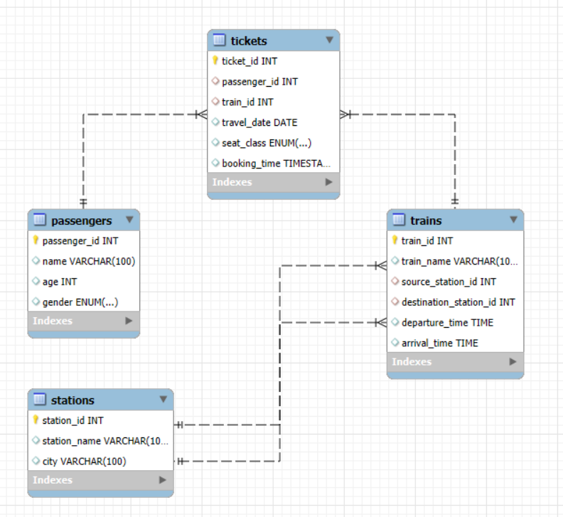

**Analysis**

* To find the most crowded route.
* To find day Bookings Trend
* To Find passenger average age wise travel through different trains.
* To find Trains with average passenger age > 30
* Passengers with more than 1 booking.

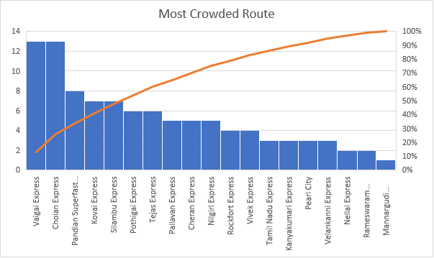

# ----End of Project----